Proposal
Version 0.2 | 14/10/2025

Grainger plc
Service Cloud Implementation - RRB

Contents
1. Executive Summary 2
1.1 Introduction 3
1.2 The Business Opportunity 3
1.3 The Project 3
1.4 The Business Benefit 3
1.5 Why Open Box 4
2. Open Box Overview 5
2.1 About Open Box 5
2.2 Purpose, Vision and Primary Goal 6
2.3 Our Clients 6
2.4 Our People 6
2.5 Qualifications & Certifications 7
2.6 Examples of Similar Work 8
3. Proposed Solution 10
3.1 Context Diagram 11
3.2 Future Functionality 12
3.3 Support 13
3.4 Training 13
3.5 Exclusions and Limitations 13
4. Project Methodology & Governance 14
4.1 Discovery Phase - Consulting 14
4.2 Sprint Zero - Design 14
4.3 Delivery 14
4.4 UAT 15
4.5 Project Management 16
4.6 Project Governance 16
4.7 Project Team 17
5. Project Costs & Timeline 18
6. Next Steps 20
- Executive Summary
- Introduction
This proposal has been prepared at the request of Grainger plc and outlines the implementation of case management functionality in Grainger’s Salesforce org that will guide users through new business processes arising from legislation to be introduced in the anticipated Renters’ Rights Bill.
This proposal outlines Open Box’s approach to the project, including the scope of delivery, delivery methodology, project governance, the project team, indicative timelines, and pricing. This document does not provide a solution design which will be delivered in the next project phase.
- The Business Opportunity
The Renters’ Rights Bill overhauls the formal rent challenge process, eliminating the risk to tenants of contesting rent increases. A systemised process to manage these legal challenges is necessary to ensure that all relevant information is captured in order to suitably motivate for the rent increase, identify undue tribunal delays that may be challenged, and keep a record of lessons learned and tribunal reasoning that may inform future rent-setting strategy and bolster future cases.
The Renters’ Rights Bill affords tenants greater rights to request a pet. This change in legislation provides an opportunity for Grainger to pilot the introduction of pet rent. Managing the pet application process within Salesforce would enable pet applications for new tenants to be coupled with the existing lead-to-lease process, and would provide a register of pets across all properties.
The Renters’ Rights Bill increases evidential standards and tightens procedural requirements, making it more challenging across the board to end a tenancy (including for antisocial behaviour). This heightens the importance of a streamlined, defensible process with clear documentation, consistent evidence gathering and properly issued notices so that landlords can still lawfully and effectively serve notice on tenants whose behaviour poses a genuine risk to others or the property. Grainger’s current process to serve notice is very manual with offline checklists and a ‘denied list’ managed in Excel. Implementing a systemised process to collate evidence and serve notice would ensure that an appropriate level of evidence is collected, stakeholders are kept informed, and tasks and follow-up activities are completed in good time.
- The Project
Open Box Software would customise case management functionality within Grainger’s Salesforce Org to manage new pet applications, ASB possession orders and formal rent challenges. In addition, a centralized, digital pet register would be created in Salesforce.
Delivering these three, separate use cases for case management in a single project will achieve a more cost-effective implementation that creates a blueprint for additional, future case management scenarios.
The project aims to strike a balance between implementing robust processes that support teams by automating aspects of the process, with the need for a cost-conscious solution that maximises value by focusing on the most critical features and leveraging standard Salesforce functionality wherever possible.
- The Business Benefit
The project has the potential to enhance the business value that Salesforce provides to Grainger and its customers with:
- A single platform with robust processes to manage ASB complaints and formal rent challenges in compliance with relevant areas of the Renters’ Rights Bill.
- All necessary information is captured in a timely manner to support legal procedures, improve the likelihood of successful outcomes, and inform future decision-making.
- Management visibility into critical processes, SLAs and KPIs.
- Enriching the single view of customer within Salesforce.
- Moving toward a single, centralised and accessible record of all customer communications.
- Improved return on investment in existing Salesforce licences.
- Improved efficiency through automations and visibility between related processes (such as new lease applications and pet applications, or tenancy reviews and formal rent challenges), thereby reducing the manual effort required to find and update related data.
- Intuitive, online pet applications for a user-friendly customer experience to help improve tenant retention.
- Why Open Box
The following benefits underscore the value and expertise that Open Box offers, ensuring successful project delivery and long-term client satisfaction.
- Global Real Estate & BTR Experience: Open Box has collaborated with leaders in the real estate industry for 24 years, including working with build to rent (BTR) clients across the UK and US. As CRE specialists we bring a unique collective intelligence within this industry, leveraging a wide range of technologies to deliver solutions tailored to address the specific challenges and opportunities within the industry.
- Salesforce Experience: Open Box, a certified Salesforce Consulting Partner, is able to design and implement new solutions, or customise existing solutions, to suit your unique needs. By ensuring you are using the right features and licenses, and that your applications are robust, scalable and well adopted within your organisation, we help you maximise the return from your investment in Salesforce and unlock the full value of the Salesforce platform.
- Grainger Experience: Open Box has worked with Grainger as a Salesforce implementation and consulting partner since 2023. During this time Open Box has developed extensive knowledge of Grainger’s Salesforce org and business operations, enabling the team to hit the ground running with any new projects.
- Proven Track Record of Delivery: Open Box has delivered hundreds of projects to high-profile Real Estate clients. Over the past two years, Open Box has successfully delivered numerous Salesforce projects for Grainger including End of Tenancy, Commercial Lead to Lease, Right to Rent, Rent Smart Wales, marketing website integration, Tenancy Review project, as well as implementing a Single View of Tenancy within Salesforce. Notably, the Tenancy Review project has already introduced Case Management to deal with tenant queries generated during the tenancy review process.
- Collaborative & Flexible Approach to Delivery: Open Box uses an agile delivery approach that encourages collaboration with stakeholders and provides flexibility to accommodate adjustments during the project. Grainger will be involved in the process, providing feedback throughout the project and will receive regular demonstrations of progress. Governance and reporting structures will be in place to ensure delivery is aligning to business needs. This collaborative approach will ensure knowledge transfer and a smooth transition to the Grainger team.
- Long-Term Relationship Focus: Open Box is committed to fostering long-term relationships with our clients by building a reliable partnership, as evidenced by our extensive history of successful project deliveries. Our commitment is demonstrated by the fact that our very first client remains with us after 24 years.
- Trusted Advisor: Open Box prides itself on being able to provide advice and thoughts on most real estate technology solutions and products, acting as a trusted advisor on items that fall both inside and outside of the current project scope. When entering a relationship with Open Box you will have someone to reach out to for any advice including demonstrations around new and future technologies.
- Open Box Overview
- About Open Box
Since 2001 Open Box has partnered with leading global real estate owners, operators, and investors to deliver technology solutions that solve real business challenges. With over two decades of industry expertise, we have developed and delivered thousands of bespoke systems and consulting projects, and we continue to support more than 100 clients worldwide.
Our services cover custom software solutions, low-code Power Platform development, data and analytics, artificial intelligence, enterprise consulting in both Yardi and MRI, CMS-based websites, SharePoint solutions, and Salesforce – always tailored to the Real Estate industry.
As a Certified Salesforce Consulting Partner with extensive real estate knowledge, we bring a combination of platform expertise and industry insight. Our team stays ahead of Salesforce developments to ensure that our clients benefit from cutting-edge capabilities while receiving practical solutions. We pride ourselves on delivering projects on time, within budget, and to the highest standards.
More than a technology provider, Open Box is a trusted long-term partner dedicated to the journey – supporting our clients to harness technology to adapt, grow, and prepare for the future as they and the industry changes.
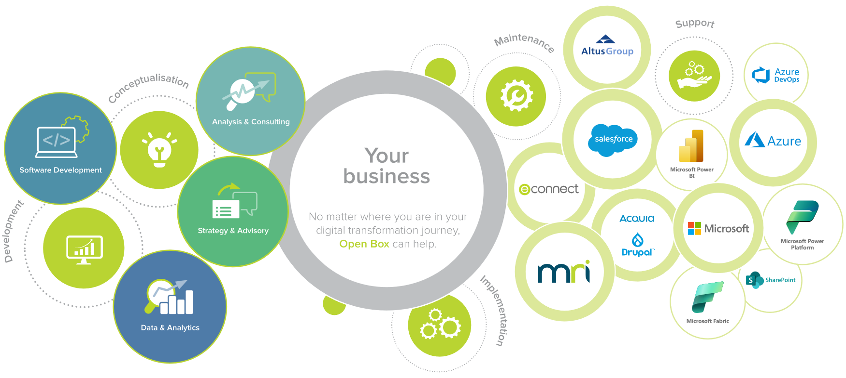
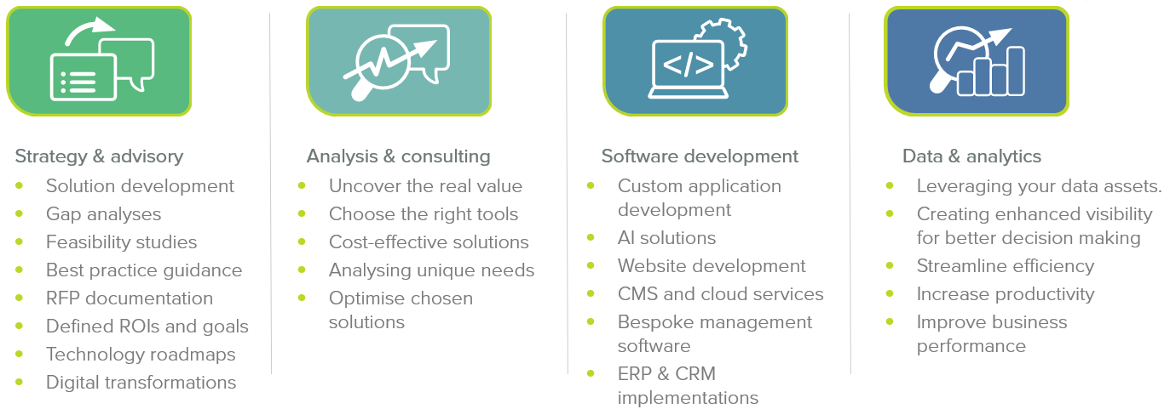
Figure 1: Open Box Service Offering
- Purpose, Vision and Primary Goal
Our company motto is simple: There’s Always a Better Way. This idea drives everything we do. Our commitment to finding a better way leads us to high-quality, long-term relationships both internally and with our clients. These relationships are our most cherished value.
Our vision is to be the technology partner of choice for top tier real estate companies, as we continually work towards a better way.
Our goal is to be a stable, respected, robust and always relevant company that specialises in delivering high-quality technology solutions to the real estate industry.
- Our Clients
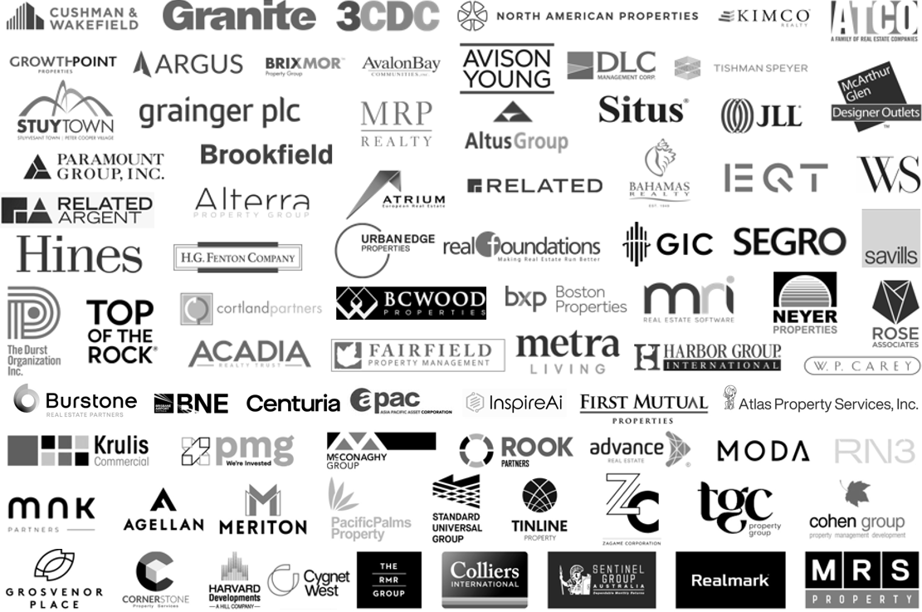
Figure 2: Examples of Our Clients
Open Box’s clients span the globe, having provided solutions across the United Kingdom, Europe, North America, South America, China, India, Australia and Africa.
We are trusted by well-known names in the industry.
- Our People
Our team comprises of over 200 staff members specialising in the major technologies relevant to the real estate industry.
Our core delivery team operates primarily out of South Africa, complemented by permanent on-site team members in the United Kingdom and North America.

- Qualifications & Certifications
All staff members are highly qualified with the vast majority holding postgraduate university qualifications in Information Systems, Computer Science, or Engineering fields.
- Microsoft
  - Microsoft Gold Certified Application Development House
  - Microsoft Certified Professionals across the Microsoft suite of disciplines
- Web/Mobile
  - Apple iOS, Android, Phone Gap / Apache Cordova / Xamarin, mobile website development.
  - HTML 5, CSS3, TypeScript and JavaScript.
  - Angular 2
- Salesforce
  - Certified Consulting Partner with 5 star customer rating
  - 61 Certifications
  - Led by Technical Architect with 18 years’ Salesforce experience
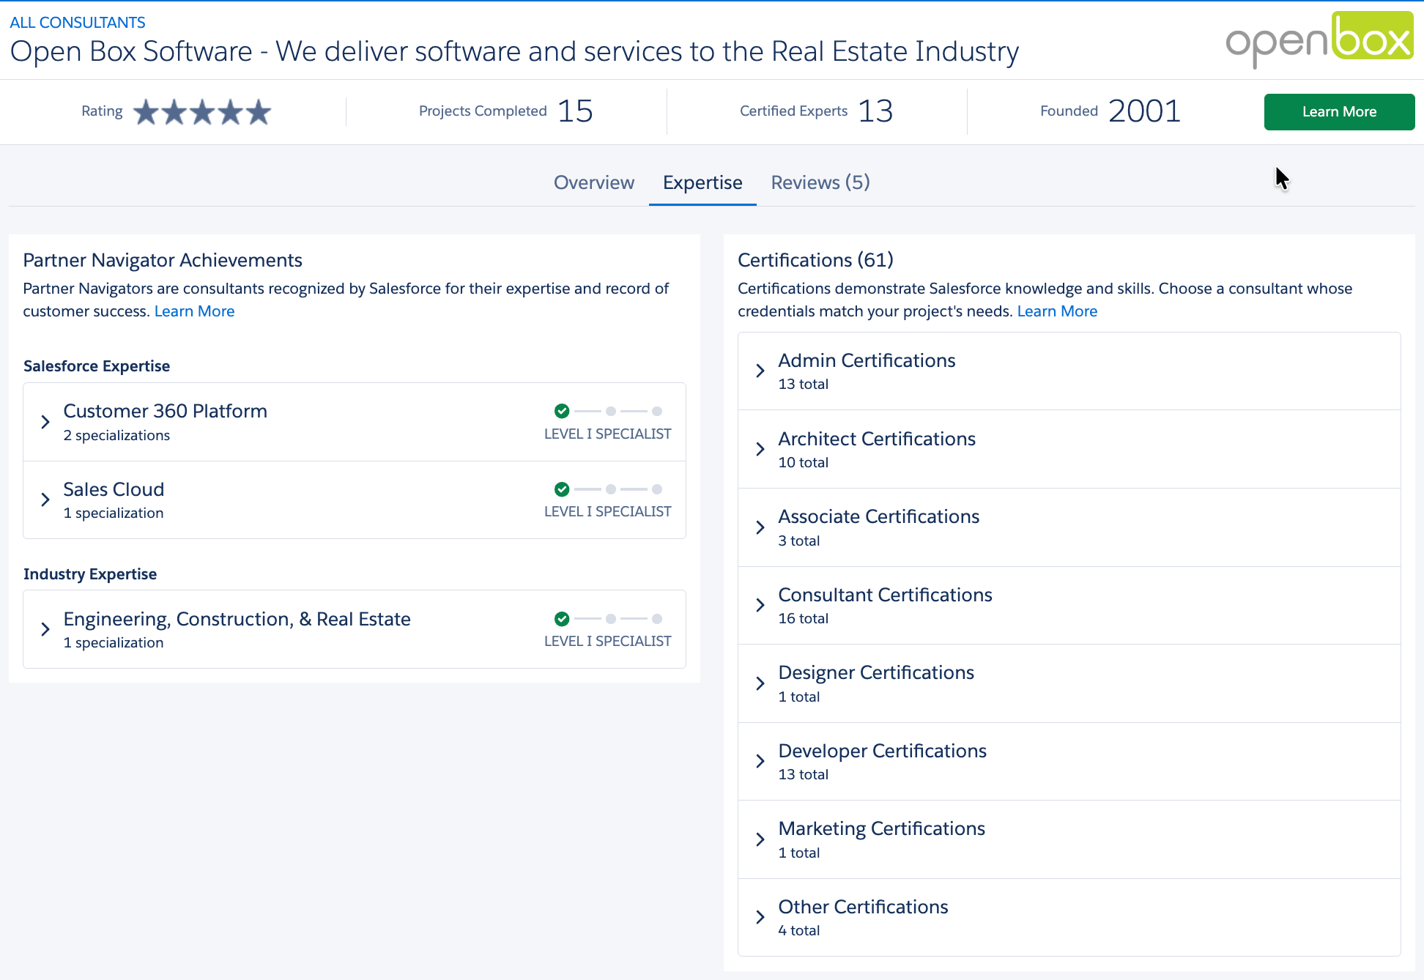
Figure 3: Open Box Consultant Listing on Salesforce AppExchange
- Examples of Similar Work
Open Box developed a Salesforce Case Management solution for a UK residential landlord, with a similar use case – providing a single place where all related information for a complaint could be compiled and actioned.
The successful project delivered using the standard Case functionality available in Salesforce and provided the following key functionality:
- A single location to capture complaint details, including communication via email between the user and the customer. This includes the full email chain as well as the ability to log calls and provide general updates to other internal users.
- Milestones to track KPIs and ensure timely completion of process, including escalations.
- Audit tracking of key fields, stage changes, completed or overdue milestones.
- Ability to link multiple complaints.
- Ability to automatically link cases to tenants and/or units based on complainant details.
- Distinct permissions to allow select users to complete certain activities, as well as restricting the visibility of sensitive cases to the appropriate users.
- Compliance with The Housing Ombudsman complaints process in terms of email templates, SLAs, etc.
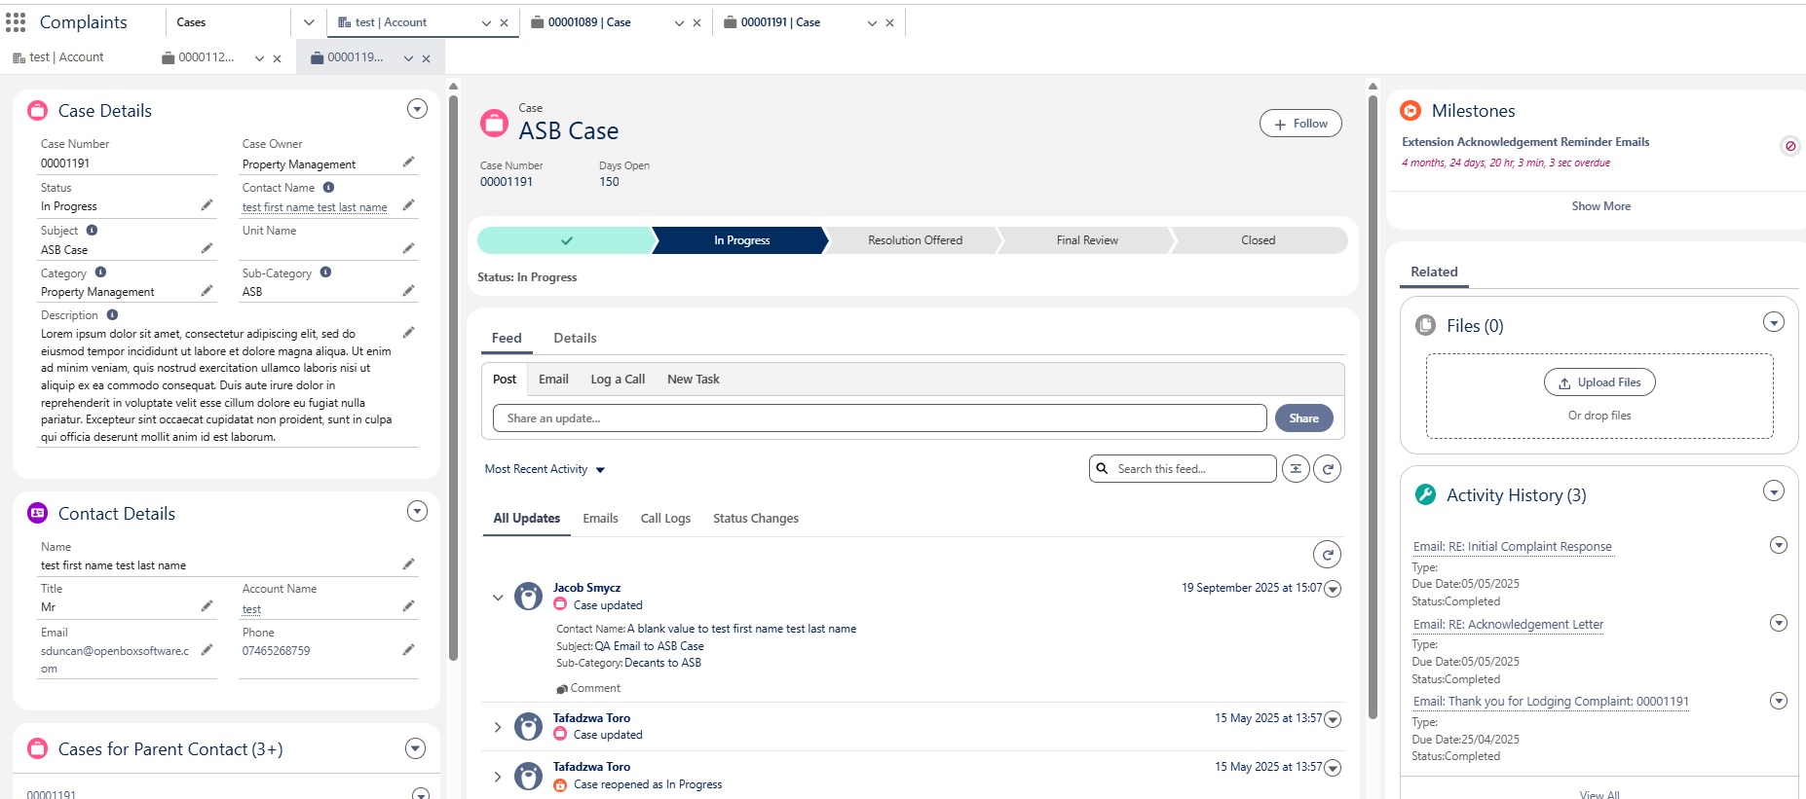
Figure 4: Case Management Functionality Delivered

    - Grainger Case Management Pilot
As part of the recent Tenancy Review project delivered for Grainger, Open Box implemented a case management pilot in the Grainger org.
In this instance case management is used for a very specific use case, namely when a customer sends an email to the dedicated Grainger tenancy reviews email address and that email cannot be linked to a tenancy review in progress.
Open Box automated the creation of a case when such an email is received, linking the case to an existing Salesforce contact (where possible), and identifying any tenancies and opportunities associated to that contact.
Given that the pilot was for a specific use case which is expected to have low volumes, case management was implemented with minimal customisation. However this functionality already provides many of the requirements identified for the proposed project, including sending and receiving communications through the case, the ability to create linked tasks, capture notes, and attach files.
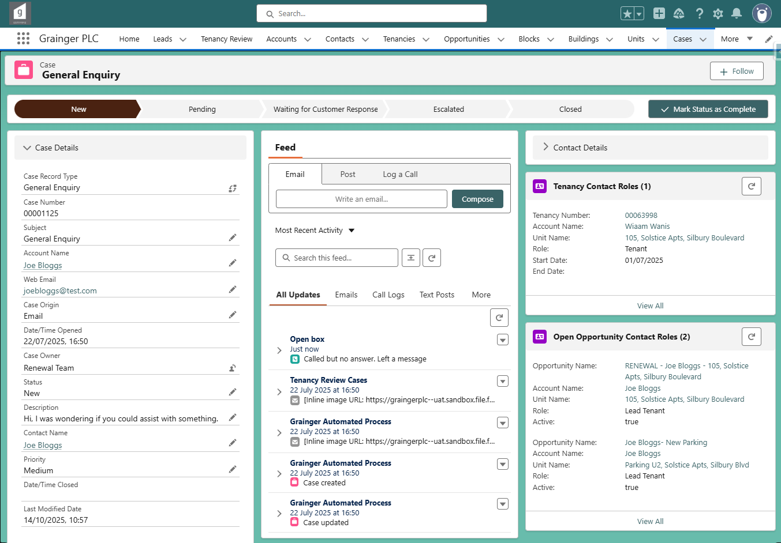
Figure 5: Existing Grainger Case
- Proposed Solution
Open Box proposes to implement customisations in the Grainger Salesforce Org to manage ASB possession orders, formal rent challenges and pets.
The solution will address the following objectives:
- Manage ASB Possession through customised Salesforce cases that guide users to capture the required information & complete the necessary tasks at each stage of the process.
  - Users would be alerted to potentially duplicate cases using standard Salesforce matching & duplicate rules.
  - A full history of evidence (such as photos and videos), comments and communications would be saved against the case.
  - User access to sensitive case information would be restricted.
- Manage Formal Rent Challenges through cases that prompt users to capture the requisite information to respond to the challenge and to track delays.
  - Formal rent challenge cases would be linked to the related tenancy review opportunity, ensuring the tenancy review is not progressed while the rent challenge is in progress.
- Manage Pet Applications for new and existing tenants through cases that would accommodate multiple pets. Pet applications would routed to the relevant team for approval; notifying tenants of the outcome and next steps.
  - Tenants and applicants would complete an online pet application form which existing tenants may access from the MyGrainger app.
- Create a Centralised Pet Register – Pet application cases would automatically update a pet register that would enable a full history of current and prior pets to be maintained.
  - Users would be able to search pets across the portfolio and drill down to see pet details such as a photo, related documents, approvals and a history of updates.
  - Current and prior pets would additionally be visible for each tenancy.
- Manage the Removal of Pets Mid-Tenancy through cases that ensure the relevant users update the pet register, end or amend the pet licence, and end or reduce the pet rent in Qube, as necessary.
- Notification to End Pet Rent at End of Tenancy – Updates to the End of Tenancy (EOT) tasks would notify the applicable teams to update the pet register and end pet rent in Qube, on confirmation of move-out.
- Usability – The solution would deliver case design that provides consistency across all case types for ease of training & adoption, as well as the ability for users to pick up a case they have not worked on before and easily know what needs to be done next.
- Leverage Standard Salesforce Functionality wherever possible to minimise customisations. Standard case management functionality includes the ability to attach documents and files, capture comments, capture call logs, automate case assignment, create and assign tasks, and see a case history that tracks changes to key fields.
- Centralized Case Communications – All outgoing emails related to a case, as well as any replies to those emails, would be visible on the case’s activity timeline within Salesforce.
  - Automated Email Notifications would be sent using standard Salesforce auto-response rules (such as confirmation to a tenant of a new pet application).
  - Email Templates would be available to assist users sending standardized notifications.
- SLA Tracking & Escalation – SLAs would be tracked and escalations automated using standard Salesforce case milestone functionality. Users would be able to see target completion dates and a visual indicator of whether each milestone is approaching due date, overdue, or complete.
- Operational Dashboards would provide easy access to information, items to be worked on and KPIs.
- Context Diagram
The following provides an overview of the proposed solution’s users and interfaces:
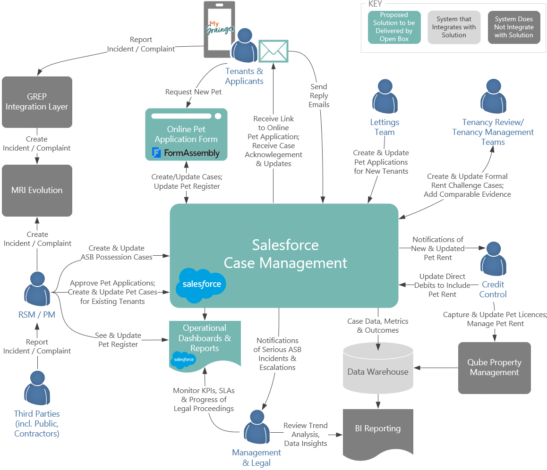
Figure 6: Proposed Solution Context Diagram
The proposed solution would leverage Grainger’s existing Salesforce licences and technology stack.
- Salesforce Case Management – Case types would be created for each scenario to be managed, each with its own workflow, milestones, SLAs, business rules and validations.
  - The case management functionality delivered by this project would lay the foundation for future use cases (see Future Functionality), working towards an end goal of creating a single platform to manage all customer interactions.
- FormAssembly – Tenants and applicants would be able to submit a pet application through an online form implemented in FormAssembly that integrates directly with Salesforce.
  - The form could be embedded in the Grainger website in a similar manner to the current FormAssembly forms used for website leads and in the tenancy review process.
- MyGrainger App – Links to open the FormAssembly form could be added to the MyGrainger app for tenants; alternately links could be sent via email.
  - It is not expected that the initial project would introduce any new direct integration between Salesforce and the MyGrainger app.
- Operational Dashboards & Reports - Operational reporting would be addressed in Salesforce.
- Data Warehouse & BI Reporting - Advanced reporting and analytics (such as trend analysis or heatmaps) would addressed using Power BI driven by the Grainger data warehouse that includes data from Salesforce as well as other applications.
- MRI Evolution – Incidents, complaints and grumbles would continue to be managed in MRI Evolution; the details of any ASB-related incident or complaint would need to be re-entered into Salesforce to create the ASB Possession case. However, moving incident management into Salesforce in future would enable integration between related cases; see Future Functionality.
- Qube Property Management – In order to right-size the project, users will be required to manually enter pet licences into Qube initially. Automation may be addressed in future releases.
- Future Functionality
The functionality to be delivered in the initial release would lay the foundation for further workflow automations and additional use cases for case management.
Additional functionality that is not included in the scope of this project as outlined above, but which may be addressed in future releases, includes:
- Enhanced Pet Management
  - Manage pet capacity limits and pet policies, enabling users to see where a building is at, or reaching, capacity.
  - Generate and send pet licences for tenants to sign.
  - Automate the creation of new pet licences in Qube via GREP integration.
  - Automate the approval or rejection of pet applications where possible.
  - Allow new lease applicants to respond to a rejected pet application online by indicating whether they wish to proceed without pet or cancel the new lease application.
  - Send automated reminders to tenants to submit updated vaccination records & pet insurance documents.
  - Enable tenants to complete an online form to notify Grainger that a pet has been rehomed or passed away which could be accessed from the MyGrainger app.
  - MyGrainger app integration, enabling residents to create and monitor pet applications and manage pet details directly in the app.
- Enhanced Formal Rent Challenge Case Management
  - Generate reply forms and documents to support written representation based on case information.
  - Automatically sourcing comparable rent.
- Enhanced ASB Possession Case Management
  - Auto-suggest case severity to users based on guided questions.
  - Link multiple reports of an incident to a single case.
  - Ability to merge duplicate cases.
  - Generate a report of case details to send to solicitors.
  - Generate and send warning letters to tenants, requesting acknowledgement of receipt. (Note that if a warning email is deemed sufficient, this may be addressed within the scope of the initial release.)
- Managing Complaints, Grumbles & Incidents (including near miss & injury incidents) using Salesforce case management that includes compensation approval workflows, SLAs and audit trails.
  - Enable reporters (tenants and third parties) to submit reports (that may include ASB evidence where applicable) via an online form or the MyGrainger app.
  - Creating visibility by linking related activity (such as a complaint about a tenancy review negotiation to the tenancy review opportunity that contains the full history of communications and negotiations).
  - Enabling users to create a linked ASB Possession case or update an existing ASB case, from an incident or complaint, prepopulated with relevant details.
- Managing Rent Collections & Arrears using Salesforce case management with workflows that include payment-plan tracking and integration to Qube.
- Alternate Possession Case Workflows – Customising possession case workflows arising from rent arrears or other scenarios.
- Managing Repairs & Maintenance Issues (for non-Axis buildings) using Salesforce case management that includes digital intake, automated case creation and case tracking from the MyGrainger app.
  - Enabling users to create a work order case from a complaint or incident, where required.
  - Providing notifications to contractors, including informing contractors of uncaged pets before onsite visits.
- Centralized Management of All Ad Hoc Communication from Customers using Salesforce case management that automates case creation from website queries, emails to feedback@graingerplc.co.uk, and general enquiries from the MyGrainger app.
  - Assigning cases to the relevant team for follow-up, or responding from standard templates.
  - Ability to easily convert queries to a complaint or maintenance issue, where required.
- Providing Knowledge-Backed Q&A such as customer self-service and Salesforce Agent Assist.
- Leveraging AI to provide Actionable Insights such as assessing formal rent challenge lessons learned and tribunal reasoning to suggest how to best achieve future rent increases; automating the identification of undeclared pets; and predictive analytics to assess the likelihood of pet ownership.
- Support
Open Box will provide post go-live support for 10 working days immediately following the production deployment.
After this period, any critical production issue will be addressed by the existing support agreement with Open Box. Any non-critical changes may be addressed though the existing BAU contract.
- Training
Open Box will deliver a training manual for end users, detailing the solution functionality. Grainger will be responsible for end user training and change management.
- Exclusions and Limitations
In order to right-size the proposed project, certain functionality will be excluded. The following is not included in the project cost estimate:
- Future functionality listed above.
- Integration with the exception of Salesforce integration to FormAssembly. Grainger, or an integration partner, would be responsible for any enhancements to the MyGrainger app to add links to online forms, data warehouse integrations to source case and pet data, as well as embedding FormAssembly pages in the Grainger website if required.
- BI Reporting
- Data migration (including prior or current ASB possession cases).
- A once-off project to populate the pet register with existing pets is expected to be addressed through a separate project or the existing BAU FTE engagement.
- This project does not include all functionality required for the Renters’ Rights Bill, including the generation of the new Section 13 documents.
- Informal rent challenges will continue to be managed via the tenancy review process; additional case functionality is not required.

- Project Methodology & Governance
The delivery approach will be based on the agile SCRUM framework. An agile delivery approach allows for the early delivery of outcomes and provides flexibility to adjust for any unforeseen opportunities or issues uncovered during the project.
- Discovery Phase - Consulting
Open Box will work with the Grainger stakeholders to review the requirements artefacts already documented by Grainger, reach consensus on the functionality to be addressed in Salesforce, and identify functionality that is best addressed in other systems or can be deferred for future enhancements.
Open Box will use their Salesforce and business analysis expertise to shape a future-state design that aligns with Salesforce features, best practices and minimises technical debt.
Open Box will deliver:
- A solution proposal and statement of work document that includes:
  - A high-level solution design for the features to be delivered.
  - A revised forecast of the number of sprints, cost & timeline required to deliver the proposed feature backlog.
  - A mock-up of the case layout template.
- A feature backlog in Jira that captures the outcomes to be delivered and proposed implementation approach.
  - The features will be sized and prioritized relative to each other.
  - This feature backlog will be used during an iterative delivery phase to identify, develop and deploy the most valuable features.
  - Any features identified for possible future releases will also be added to the backlog.
On completion of this phase Grainger will decide whether to continue with the project, reassess the project scope, or halt the project.
If necessary, discovery for the Formal Rent Challenge functionality could be deferred and completed in parallel with development of the ASB & pet management functionality, once there is more clarity around the Renters’ Rights Bill.
- Sprint Zero - Design
During a Sprint Zero phase, Open Box will work with the core Grainger project team in backlog refinement sessions to break down the features identified in the discovery phase into detailed user stories with acceptance criteria and technical designs.
Sprint zero will not deliver all user stories to be addressed in the project, but will provide a sufficient backlog of user stories that enables the delivery team to commence development.
- Delivery
Iterative delivery is achieved through a series of 3-week sprints.
The backlog of features and user stories will be maintained to track outcomes to be delivered and indicate priority of these outcomes relative to each other. The backlog will be a living artifact that will evolve as Open Box and Grainger collaborate and will serve as the single source of truth with regards to scope.
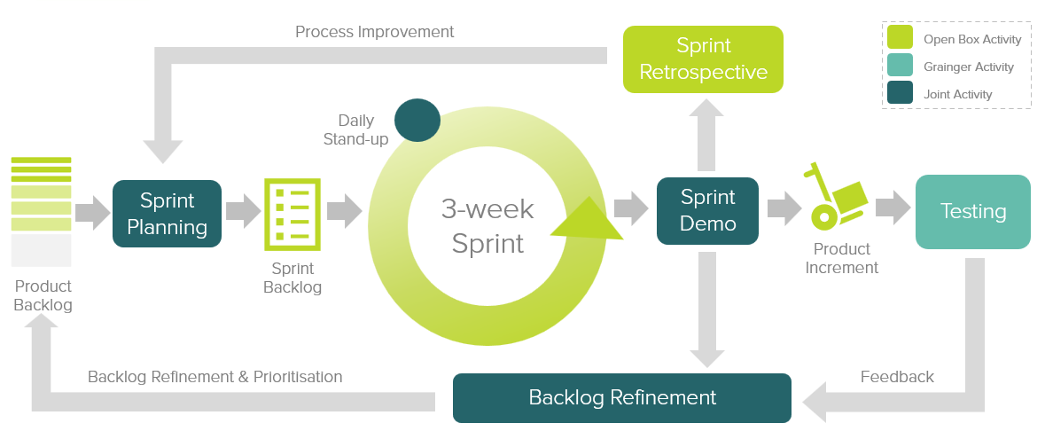
Figure 7: Agile Delivery Approach
Grainger representatives will participate in the following during each sprint cycle:
- Backlog Refinement – Open Box and Grainger representatives will meet to prioritise user stories on the backlog as well as review and agree on acceptance criteria for user stories at the top of the backlog.
- Sprint Planning – Outcomes on the backlog will be selected for the next sprint.
- Demo – Open Box will meet with Grainger representatives to demonstrate the outcomes delivered in the past 3-week period.
- Testing – Open Box will be responsible for unit testing and QA testing of functionality. Grainger representatives will conduct user acceptance testing of new functionality delivered in each sprint and provide feedback.
- Stand Up – Daily, 15-minute stand up calls will be held for the Open Box team to internally report on progress. Weekly, 30-minute stand up calls will be held with the Grainger team to identify upcoming deliverables, discuss potential blockers, provide feedback and give input on any questions that arise.
Feedback from demos and testing will be classified as either bugs or enhancements (depending on the user story and acceptance criteria). Bugs will be fixed in a subsequent sprint, whereas enhancements will be incorporated into the backlog and prioritized accordingly.
If it is expected that the critical functionality can no longer be delivered within the estimated cost and timeline, this will be communicated to Grainger who may choose to resolve this by adjusting the project scope and/or cost & timelines accordingly.
- UAT
Designated Grainger business users will be given access to a UAT sandbox to test the functionality end-to-end and ensure that the overall solution is functioning as expected.
Issues raised will be classified as bugs or enhancements (as above). Bugs will be fixed during the UAT period. Any other enhancements or new requirements will be added to the backlog for future development.

- Project Management
Open Box will deliver a progress report to Grainger on a regular basis, that will include:
- General status update
- Project risks
- Project milestones & timeline forecast based on the current scope.
Regular updates regarding any significant changes in scope or cost will be delivered to Grainger as and when they occur.
- Project Governance
The below meetings will be held for the governance of the project to ensure effective oversight, decision-making, communication and alignment with project objectives.
- Kick-off Meeting
  - This will occur once at the start of the project to formally launch the project and ensure all stakeholders have a clear understanding of the project goals, scope, governance structure, roles and responsibilities.
  - Grainger attendees: Project sponsor (lead), project manager, project team members, additional stakeholders.
  - Open Box attendees: Project manager and key project team members.
- Steering Committee Meetings
  - These will be scheduled periodically, in consultation with Grainger, to provide high-level oversight and strategic direction for the project and demonstrate progress to date. The steering committee will review project progress, major issues, scope changes, and ensure alignments with business goals.
  - Grainger attendees: Project manager (lead), project sponsor, steering committee.
  - Open Box attendees: Project manager, architect, business analyst.
- Programme Management Meetings
  - This will occur every 3 weeks to provide updates across all current Open Box projects, track progress against milestones, identify issues and review risks.
  - Grainger attendees: Project sponsor (lead), project manager.
  - Open Box attendees: Project manager, architect.
- Weekly Stand-Ups
  - This will occur weekly to provide progress on tasks, identify any obstacles and ensure everyone is aligned on immediate tasks and priorities.
  - Grainger attendees: Project manager, key project team members.
  - Open Box attendees: Project manager (lead), key project team members.
- Sprint Retrospectives
  - This will occur after each sprint to review the latest sprint to assess and identify improvements for enrichment of future sprints.
  - Open Box attendees: Project manager (lead), project team members.
- Post-Project Review
  - This will occur at the end of the project to review the project’s outcomes, lessons learnt and performance against the original objectives.
  - Grainger attendees: Project manager (lead), project sponsor, project team members.
  - Open Box attendees: Project manager, key project team members.

- Project Team
The project team is anticipated to be comprise of the following team members:
Table 1: Proposed Project Team
Role | Name | Experience
Salesforce Technical Architect | Sam Duncan | Salesforce architect and principal consultant with 18 years Salesforce experience. 18X certified.
Project Manager | Shaun Barrett | 20+ years project management experience with 11 of those years focussing on commercial real estate projects.
Senior Business Analyst | Nikki Papenfus | 16 years analysis experience on commercial real estate projects.
Residential Lettings & Operations SME (UK-Based) | Jacob Smycz | 6 years working at Grainger plc / BTR experience. 7X certified
Senior Developer | Anjali Salecha | 18 years Salesforce development experience. 9X certified.
Developer | Mathew Cornfield | 3 years Salesforce development experience. BSc. Hons. Computer Science. 3X certified.
Quality Assurer | Khonani Davhana | 3 years Salesforce QA experience. BTech, Electrical, Electronics & Communications Engineering. ITQSB and 1X Salesforce certified.

Individual project team members may be substituted, at the discretion of Open Box, for others of similar skills and experience. The availability of specific individuals is subject to project timelines.
    - Availability
Open Box resources will be contactable and available for meetings via conference calls/video conferences:
- Monday to Friday 9am – 6pm South African time which corresponds to 7am – 4pm GMT, excluding public holidays.
All consultancy and all development work will be completed by Open Box offsite.
- It is not expected that the project requires Open Box resources onsite. Where onsite personnel are required, all reasonable expenses for travel and subsistence shall be reimbursed by Grainger. Open Box shall not bill any mark-up or administration fee onto any such expenses. Approval for expenses shall be obtained from Grainger prior to being incurred.

- Project Costs & Timeline
Open Box will provide the following services:
- Discovery Consultancy & Sprint Zero:
  - An Open Box Salesforce Technical Architect, Senior Business Analyst and Residential Lettings & Operations SME will be available on a time & materials (T&M) basis.
  - Time spent on these phases will not exceed upper bound estimates without prior approval from Grainger.
- Build Phase: An agile sprint team delivering in 3 week sprints. The team will be staffed to include the following skill sets as required:
  - Salesforce Technical Architect
  - Business Analyst
  - Residential Lettings & Operations SME
  - Developer
  - Quality Assurer
  - Project Manager
- UAT support to assist in the UAT process and fix any new bugs identified.
- Production deployment and post-go live support immediately following the production deployment.

The total cost of this project is estimated to be £107 890 – £138 980.
The total duration of this project is expected to be 20 - 23 weeks, including 2 weeks UAT and an additional 2 weeks for post go-live support.

Table 2: Estimated Project Cost
Phase | Duration | Lower Bound | Upper Bound
Discovery | 4 weeks | £ 13 040 | £ 16 300
Sprint 0 | 3 weeks | £ 13 040 | £ 16 300
Build: 3 – 4 Sprints | 9 - 12 weeks | £ 73 710 | £ 98 280
UAT | 2 weeks | £ 4 095 | £ 4 095
Production Deployment & Post Go-Live Support | 2 weeks | £ 2 048 | £ 2 048
User Guide | Done in parallel with sprints | £ 1 958 | £ 1 958
Total | 20 - 23 weeks | £ 107 890 | £ 138 980

Assuming a project start date of 1st November 2025 (and a 2-week December break over the festive season), the estimated project timeline would be as follows:
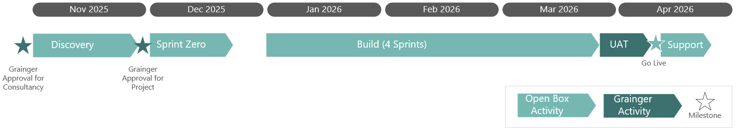
Figure 8: Estimated Project Timeline

All amounts are quoted in GBP (£) and exclude VAT, if applicable.
Project costs will be billed monthly, in arrears.
The quotation for the discovery phase is valid for 30 days.
- Next Steps
The proposed next steps are:
- Grainger to confirm -
  - Intention to proceed with the project
  - Expected project start date
  - Whether the discovery for the Formal Rent Challenge functionality can proceed or needs to be addressed in a separate phase.
- Open Box to provide a Statement of Work for the discovery phase.
- Grainger to approve the Statement of Work.
- Open Box to complete discovery analysis, deliver the artefacts detailed above (see Discovery Phase Consulting) including an updated cost estimate.

